Regress # Aggravated Assaults on:

* Median house value (in $1000)
* Presence of Parks (Y=1/N=0)
* Police Unit Serving Block Group (A, B, C, or D)

We create 3 dummy (Y/N) variables from the community policing unit variable:

* Dummy A (1 if block group served by community policing unit A; 0 otherwise)
* Dummy B (1 if block group served by community policing unit B; 0 otherwise)
* Dummy C (1 if block group served by community policing unit C; 0 otherwise)

Our regression equation is:

$$y=AggAssaults= β_{0}+β_{1}MEDHVAL+β_{2}PARKS+β_{3}DUMMYA+β_{4}DUMMYB+β_{5}DUMMYC+ε$$

Regression Results:

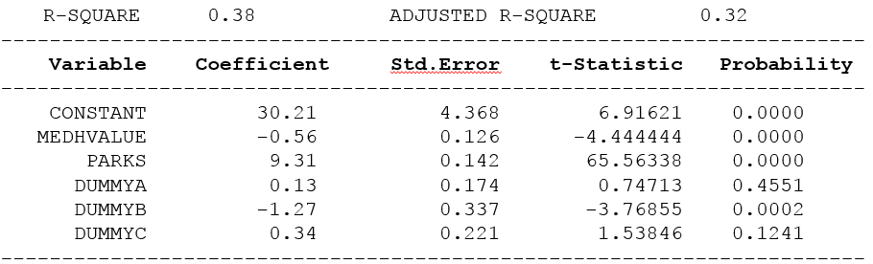

Our regression equation becomes:

$$\hat{\hat{y}=AggAssaults}= 30.21-0.56 MEDHVAL+9.31 PARKS+0.13 DUMMYA-1.27 DUMMYB+0.34 DUMMYC$$